CS628 – SAI SATHYAK NALLAMALLI ASSESMENTS REDOING

PE04:

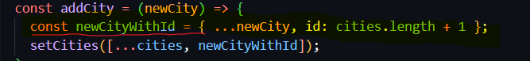

Had to take help for this these scripts statement as I was facing error all along

References which helped me with the scripts

[Using refs in React functional components (part 1) - useRef + callback ref - DEV Community](https://dev.to/carlosrafael22/using-refs-in-react-functional-components-part-1-useref-callback-ref-2j5i)

Output

